**UX Design Phase 3 Assignment**

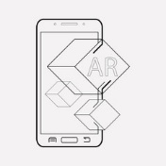**KU4**

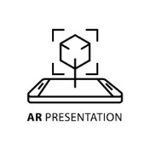

a). I chose these 3 sample icons for AR as 1). They are easy to understand, 2). If the user wants to switch back to AR mode, he/she knows which icon leads to it and 3). The info button is something which automatically you know it means more information.

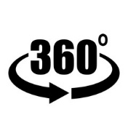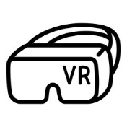

b). I chose these 2 samples for VR as 1). They basically represent the VR concept and 2). When the user wants to VR mode, he/she knows which icon to press.

c). I will be using Fra Sans as my font because as always, I choose fonts that are easy to read and nice to look at and because personally, I think it fits as a representation to write information regarding History.

**KU5**

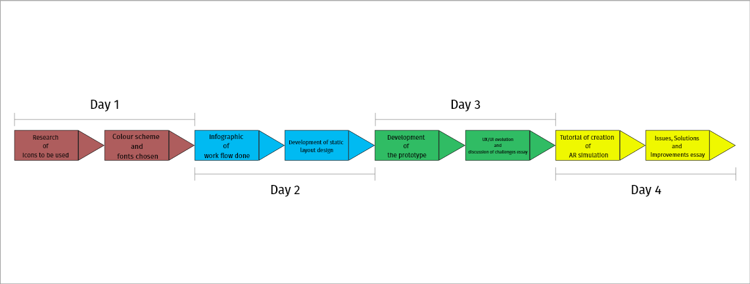

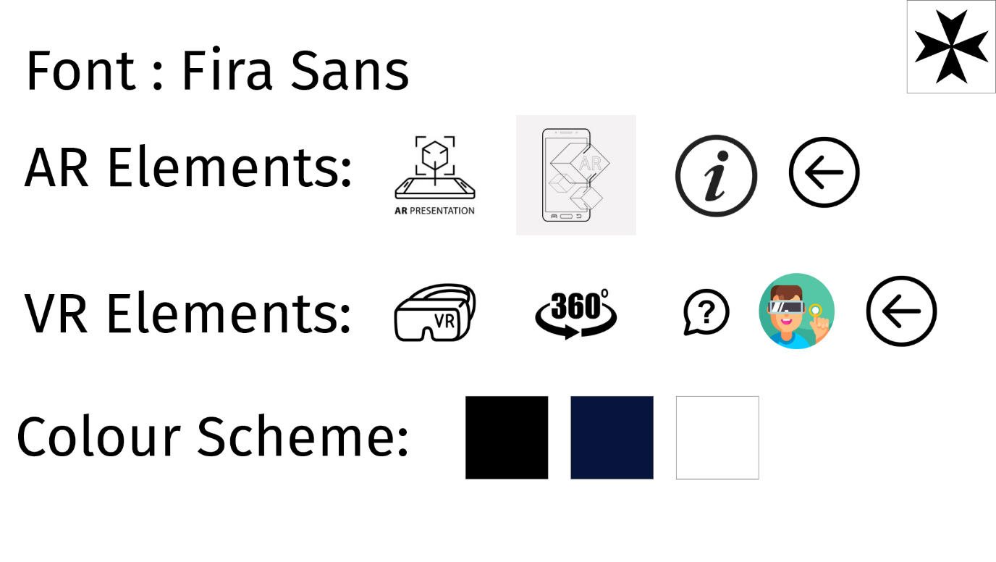**AA3**

**AA4**

-In Adobe XD Files

**SE1**

a). As I see both the colour scheme and font to be suitable for this theme.

b). See project in Adobe XD files

c). One is because it is the most common resolution.

**AA5**

-Prototype can be found in Adobe XD files

DraftXR link: https://app.draftxr.com/vr/befj5i

**KU7**

a). One very noticeable change that impacted UX designers was the introduction **of Artificial Intelligence**. This I by far the coolest tech trends there is right now. An example of AI that is becoming noticeably common now is Chatbots. They are integrated with websites or messaging apps to help businesses automate their regular tasks from getting customers information about best hotels or lowest flight prices, all the way to booking them. AI impacted UX for sure due to its delivery of information in seconds. This way customers can receive more thorough and immediate care than they got previously. If it is built correctly, it can also result in reduced or no human error at all. Another technology that impacted UX designers for sure was **Visual Recognition**. This was something revolutionary. This helps to distinguish elements on images like people, objects, plants, or even texts. It won’t be necessary to spend so much time observing CCTV cameras because they will be able to alert us about any strange activities. Probably in some time, more stores will be automated to replace long queues for checking out and speed up retail transactions with the help of computer vision, deep learning and sensor fusion. For sure I cannot forget to mention **VR and AR’s progress**. The technology is here and markets are ready. It has already started to change everything. Jobs, industrial work, leisure activities and with the new marketing possibilities, our whole life. In 2020, as it costs less with improved usability, it has also become accessible to the average consumer. Virtual and Augmented Reality gives a whole new dimension to UX design too. With all the tools, which are already on the market (or under development), you can give a hyper-immersive experience where all senses of the human body are influenced.

A technology that impacted UI was the beginning of **Software Implementation**. People already had a mental model of a typewriter’s keyboard; they already knew how to type, so the natural progression was to begin interacting with text on digital screens the same way. This also applies to mobile on-screen keypads that look like mini versions of the same keyboards and typewriters. With the movement toward touch, an entirely new way of interacting with our environment began to be defined. A clear example of when UI had a good leap in the future was when Steve Jobs introduced IOS 7 in 2013. Apple’s [iOS Human Interface Guidelines](https://developer.apple.com/design/human-interface-guidelines/) encouraged designers to shift the mindset from bezels, gradients, and drop shadows (which can lead to heavier-looking UI elements) and focus more on the content and allow the UI to play a supporting role. Google’s [Material Design](https://material.io/design/) also shifted towards a different representation of the third dimension by giving the entire digital canvas depth with subtle layers and drop shadows, as opposed to individual UI elements as represented in skeuomorphism.

b). **Conducting research with limited resources and time** is a very common issue with UX designers. Conducting research is always recommended, but sometimes limits resources and time can inhibit a designer’s ability to complete his task. Sometimes **UX Designers find it difficult to sculpture what the company’s vision is** and thus getting mixed in their role. The goal of UX design is to improve the relationship between a company and its customers and also to improve their experience with the services and products that are provided. Thus, the set of skills of a UX designer is complex, meaning, he or she needs to understand the business and its position in the market and to study the users’ pain points and goals to be able to create better experiences**. UX designers sometimes find it difficult to work with developers.** Designers and developers have very different yet equally important roles to play in the product development process. It’s [often said](https://medium.muz.li/how-to-bridge-the-gap-between-design-and-development-b10c5f41f5d7) that without development, design is useless, and without design, development is unusable. Collaboration between the two is paramount, but it sometimes feels like you’re speaking different languages. Another challenge that UX designers grapple with is the **seemingly never-ending list of UX job titles**. User experience design is such a broad field that over time, the UX designer role has branched off into many different areas of specialization. Companies are increasingly hiring specialists to focus on certain aspects of UX such as information architects, UX researchers, [UX writers](https://uxplanet.org/the-rise-of-the-ux-writer-8beb836c13f1), and usability analysts.

**SE2**

**Animation functionalities**

As animations I split it into two groups, The picture box and the other the hot spot.

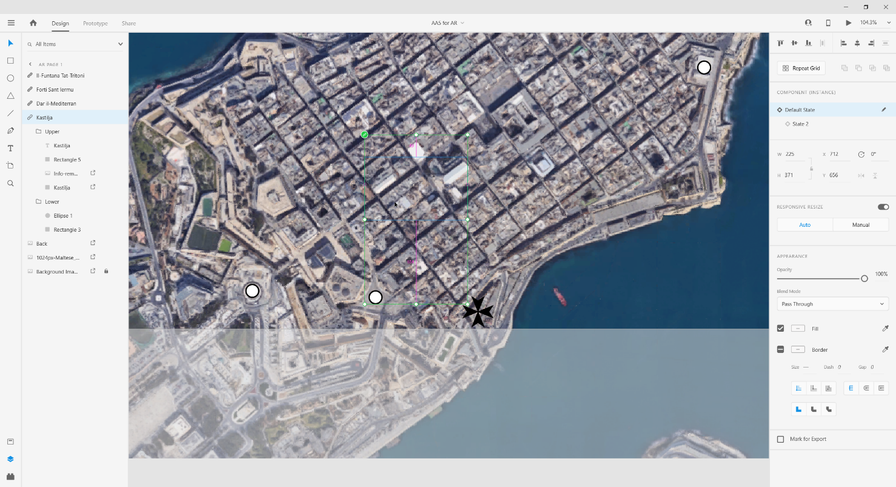In the Default State I have the Upper Group and the rectangle in the Lower Group with 0 Opacity.

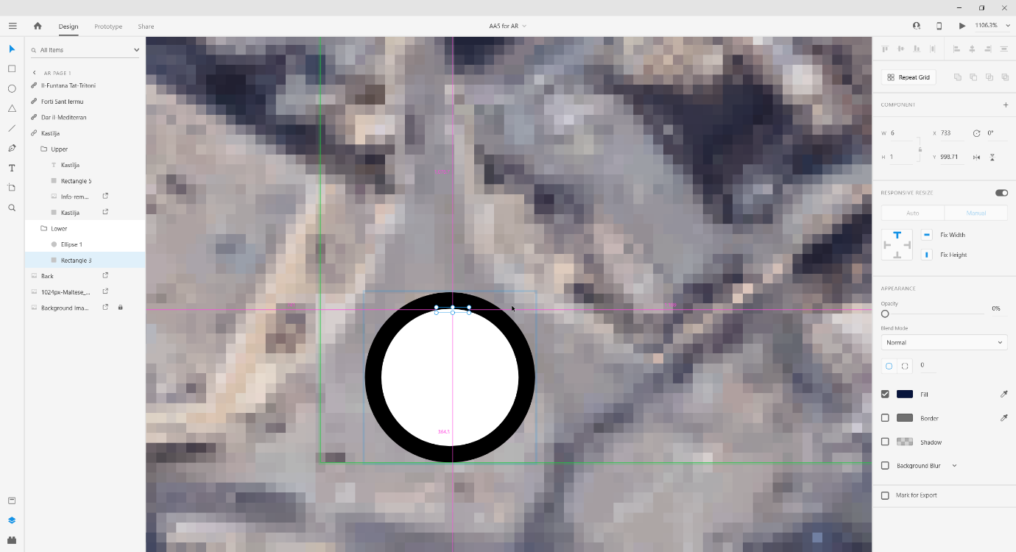The rectangle in the Lower Group I also decreased it’s with so that it has an affect that it is getting enlarged and connecting to the picture box.

In State 2 the Upper and the rectangle in Lower Group have an Opacity of 100 and the rectangle also has its width increased.

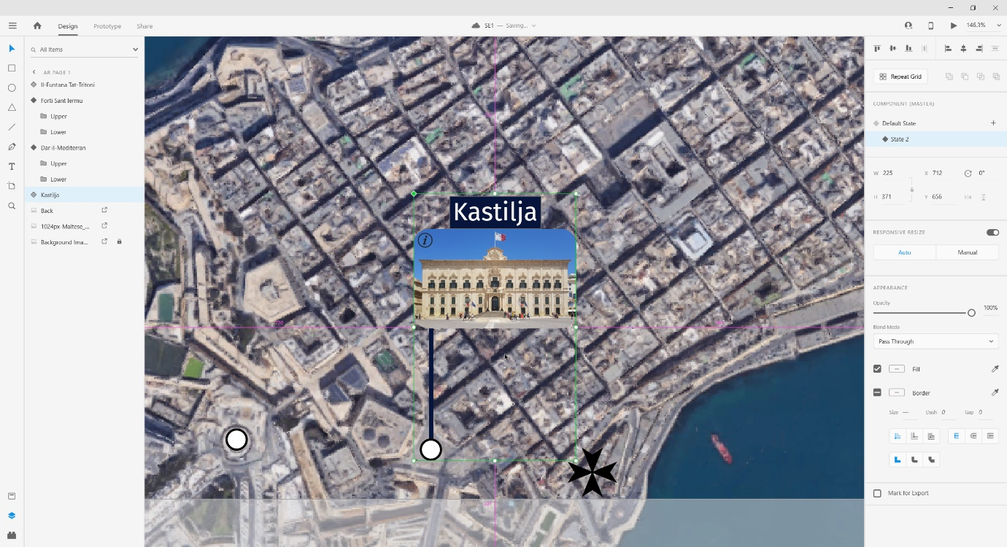

For interactives functionalities I have a Hover interaction so when the mouse is hovering on the Hotspot State2 activates and the picture box and rectangle appear creating this nice animation. When the mouse is not on the Hotspot the picture box and the rectangle go back to 0 Opacity and the rectangle at the same time decreases its width creating this closing effect.

**SE3**

a). To have a better understanding on what the developers have to implement, my job as the designer, I have to make it as easy as possible so that the right product is well made. For this case I created a template of what assets are to be used (AA3 show this perfectly). Then another template was created where the app is outlined properly. This template shows where icons need to be placed both in AR and VR, where the colour scheme and fonts need to be applied, how the animations look, when the Hover interaction is active and more (AA4 is a perfect example). I will be providing them as well a more detailed look at how the project should look like with all the colour scheme, animations, fonts and images to have a better understanding. This will include also wireframing to show the work flow of how all things must work (SE1 and AA5 shows this).

b). I would recommend using **my own images**. For example, the background image in the AR project is a satellite image of Valletta. I chose this as to give a clear picture of where the monuments are located and give the user a view of how Valletta looks from that perspective. Also, for the VR I chose those images to show a clear picture of how the monuments look like in real life. Also, I would recommend using **my icons** as I chose them to be as simple as possible and not to confuse the user where to press/click. If the user wants more information on a monument, in the VR mode, a Question Mark icon is placed directly on the monument. I also recommend **using my button placement.** I specifically placed the picture boxes where they are when opened so that no other picture box opens in the area of the hotspot. Same goes for the back button, it is placed in an appropriate spot where it doesn’t obscure any of the images or picture boxes.

c). My first improvement would be to use proper 360 images for the VR mode. With normal images the DraftXR plugin tries to create a 360 image but the image then becomes stretched it doesn’t look nice. This of course impacts the user experience the user will have as he/she won’t have a clear picture at what they are looking at which is obviously not good. Also, due to stretched images the icon placement isn’t that great as they get cramped and in the way. My other improvement would be to use a better-quality background image for the AR mode. If the user wants to zoom in and look at where the monument is on the map the image becomes blurry and pixelated and this will confuse the user. Overall, I would choose better quality images by going there in person and taking the photos in 360 myself. This also would help me better understand where to take the photos whilst next to the monument (as in what would be the best place to see the monument where it would leave an impact on you that would remind you of it) as I would she wat the tourist would see. Another improvement would be to have a better-looking landing page. This is the first thing the user will look at when opening the application and I feel this is very important. This is because when showing a more detailed and polished landing page you will leave a better impression on the user and will give them the feeling that the application is done seriously and properly and not cheap. How it is right now it looks like a work in progress application which is not what I would want the user to feel.

d). Usability wise I would have preferred that to open the Hotspot you only have to hover on the literal circle of the Hotspot. In my build you can hover on where the picture box will open and this will trigger the animation to open. Another improvement would be to connect both the AR mode and VR mode together. What do I mean about this? I would start by using the AR mode, when the user clicks on a hotspot and the picture box opens, if the user wants to view the monument in VR mode to have a clear picture of how the monument looks likes, in the picture box there would be a VR mode button that would lead the user to VR mode. If the user wants to go back to AR mode there would be a button that would lead him straight back to AR mode. This would be more efficient then having one app for AR mode and another app for VR mode for sure. Personally, this would be so much easier and more effective and at the end it would be a better User Experience for the user. For this I would use a different UX design application that allows you to have both AR and VR merged together.